Gladwin Conservation District
EQUIPMENT RENTALS
989-426-9461
www.gladwincd.org

TRUAX RENTAL

The District has a 6ft truax drill to help with
your conservation seeding. This drill will plant
cool season mixes, warm season grasses and food
plot materials. It is recommended to use at least a 40-horsepower tractor to
pull the truax.

Rental Rates
$80 Daily Operation Fee
$40 Base Fee Toward Acreage Planted
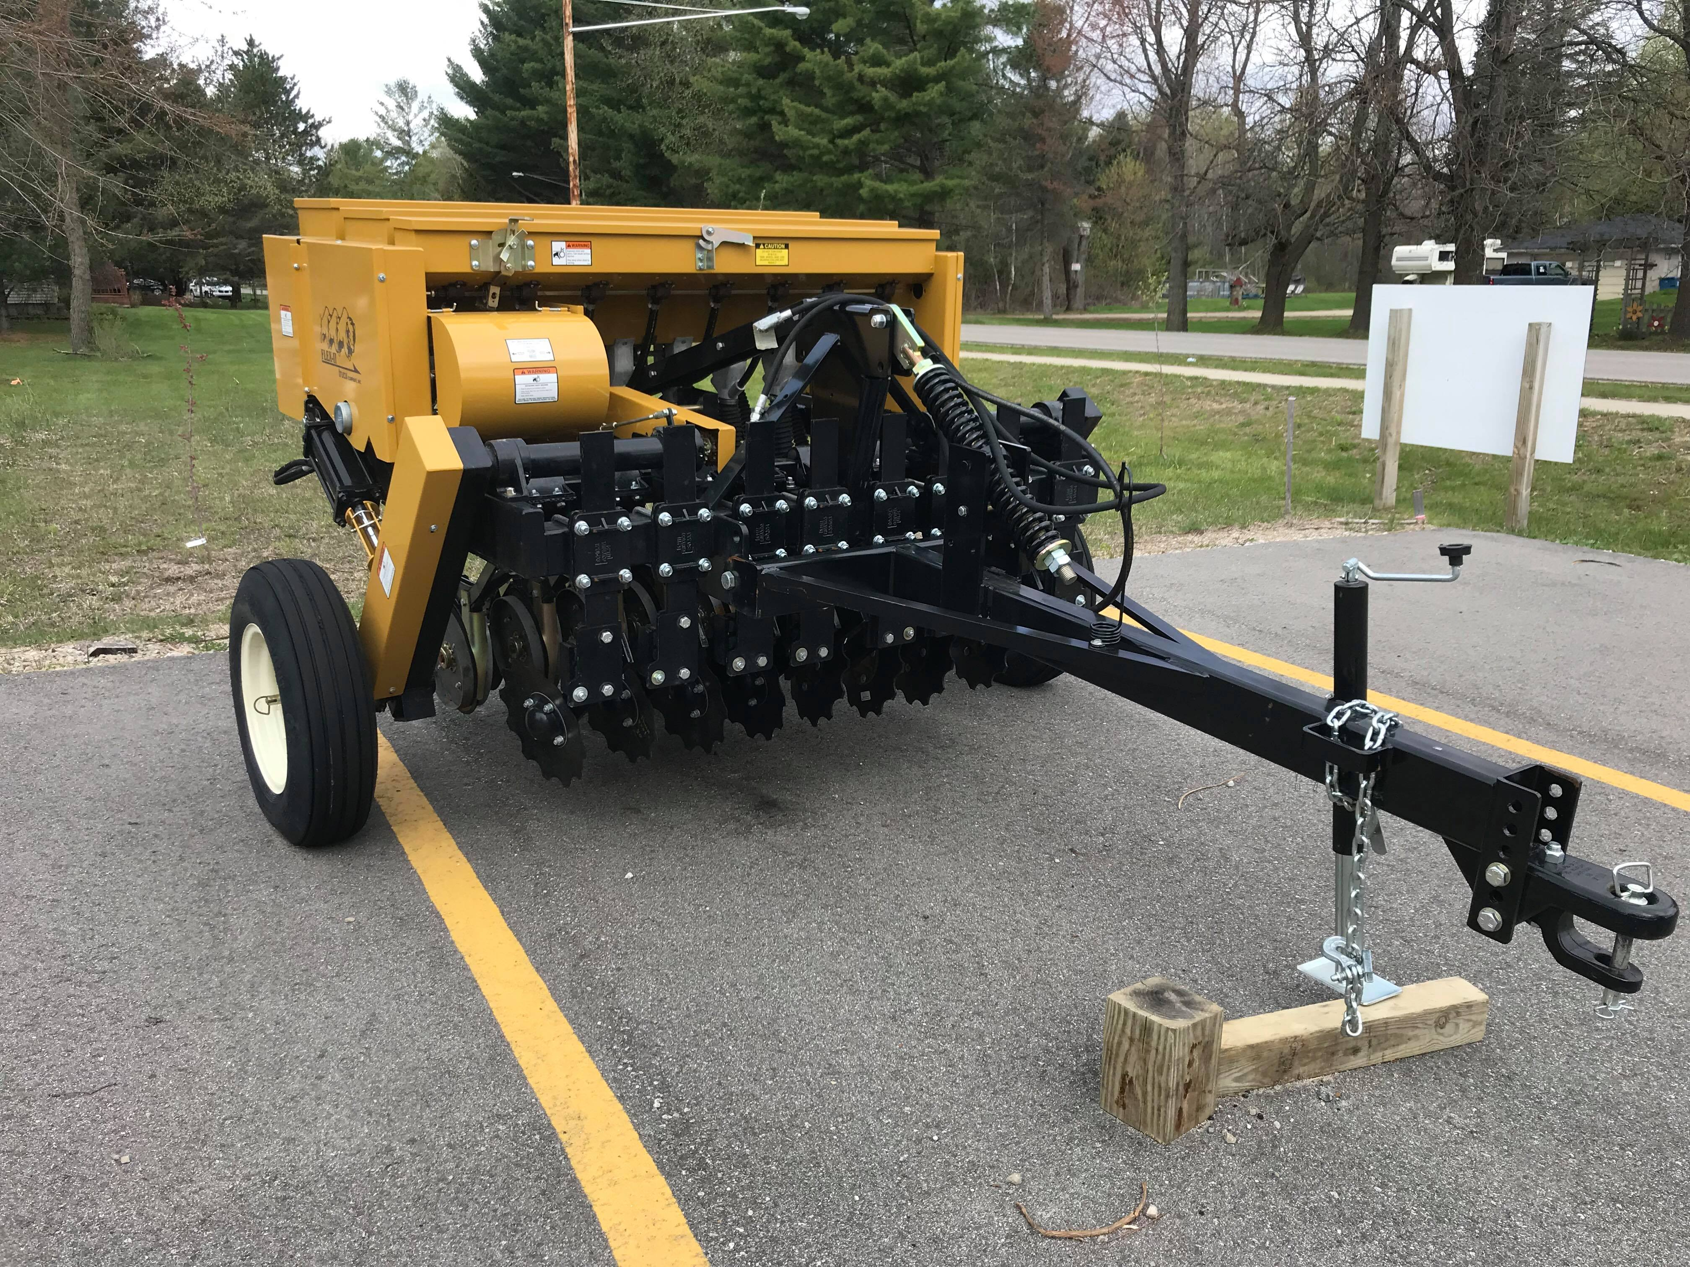
10+/ac - $8.00/ac

